**PYTHON LAB FILE**

Name: MRIDUL SINGH RAWAT

Sap id: 500119881

Roll No: R2142231074

Batch No: 32

**EXPERIMENT: 2**

1. **Declare these variables (x, y and z) as integers. Assign a value of 9 to x, Assign a value of 7 to y, perform addition, multiplication, division and subtraction on these two variables and Print out the result.**

**Output**

1. **Write a Program where the radius is taken as input to compute the area of a circle.**

Output

1. **Write a Python program to solve (x+y)*(x+y) Test data : x = 4 , y = 3 Expected output: 49**

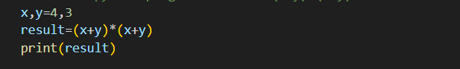

Output

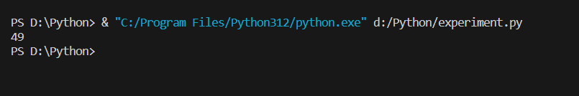

1. **Write a program to compute the length of the hypotenuse (c) of a right triangle using Pythagoras theorem**.

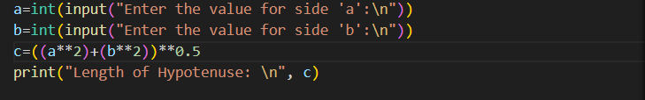

**Output**

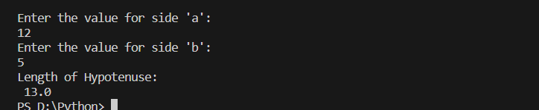

1. **Write a program to find simple interest.**

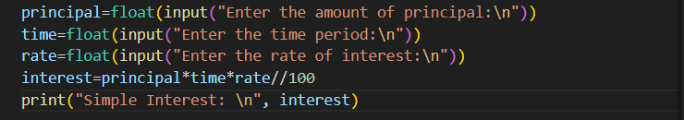

**Output**

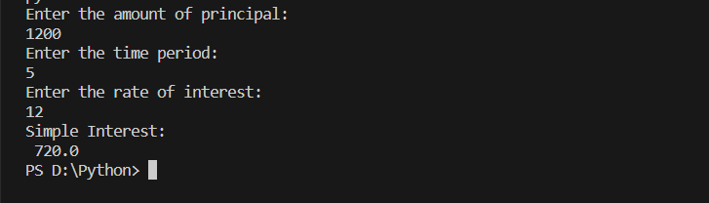

1. **Write a program to find area of triangle when length of sides are given.**

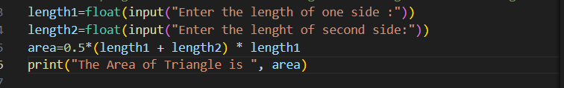

Output

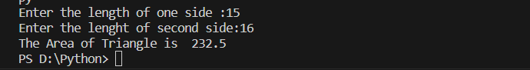

1. **Write a program to convert given seconds into hours, minutes and remaining seconds.**

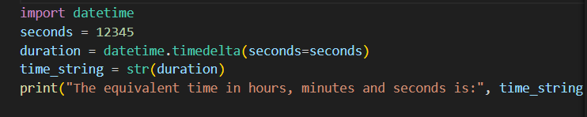

**Output**

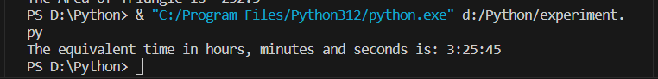

1. **Write a program to swap two numbers without taking additional variable.**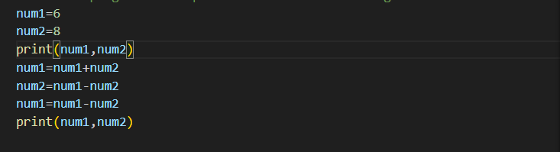

**Output**

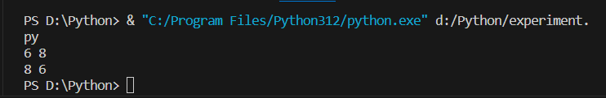

1. **Write a program to find sum of first n natural numbers.**

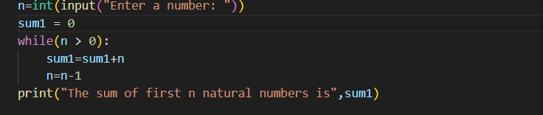

**Output**

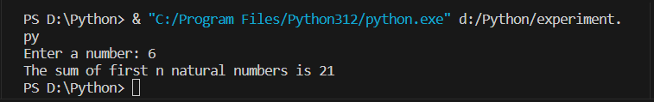

1. **. Write a program to print truth table for bitwise operators( & , | and ^ operators)**

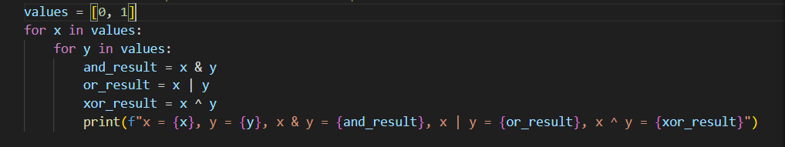

**Output**

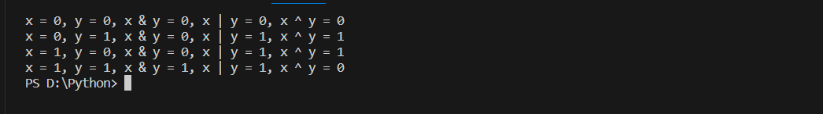

**11 Write a program to find left shift and right shift values of a given number.**

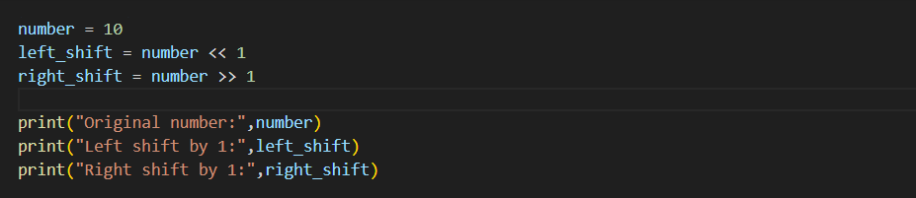

**Output**

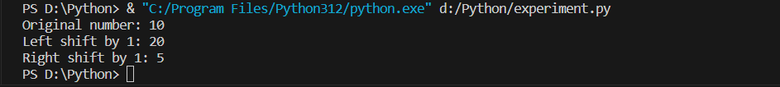

**12. Using membership operator find whether a given number is in sequence (10,20,56,78,89)**

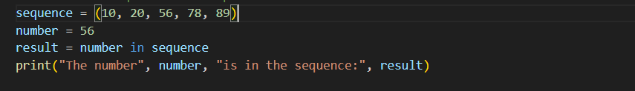

**Output**



1. **Using membership operator find whether a given character is in a string.**

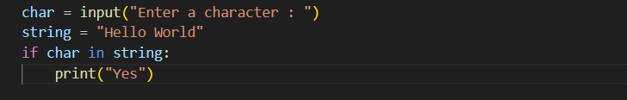

**Output**

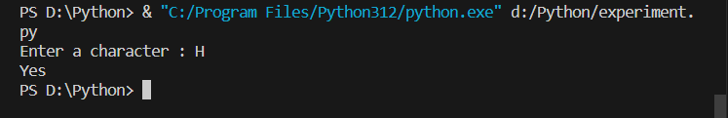

**EXPERIMENT 3**

1. **Check whether given number is divisible by 3 and 5 both.**

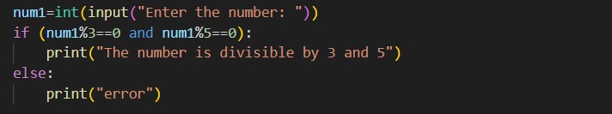

**Output**

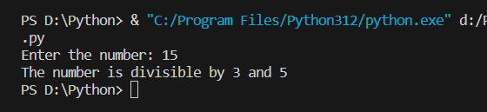

1. **Check whether a given number is multiple of five or not.**

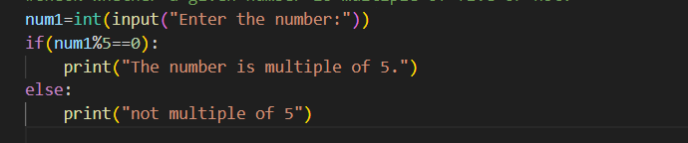

**Output**

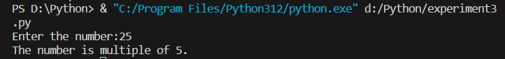

1. **Find the greatest among two numbers. If numbers are equal than print “numbers are equal”.**

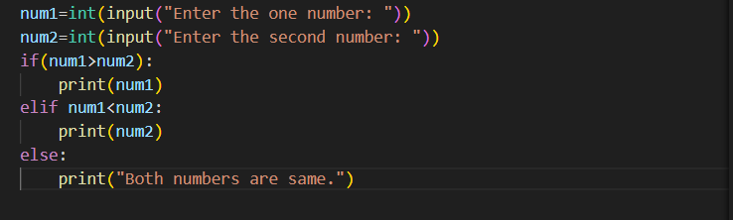

**Output**

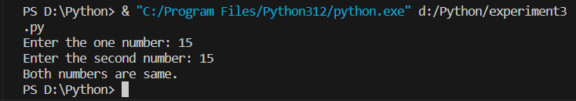

1. **Find the greatest among three numbers assuming no two values are same.** 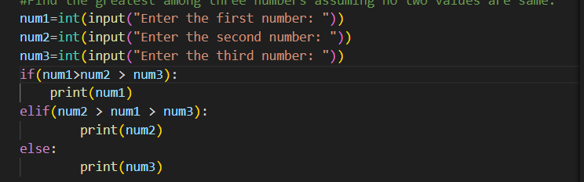

**Output**

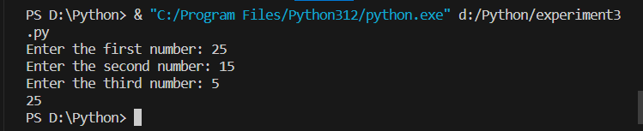

1. **Check whether the quadratic equation has real roots or imaginary roots. Display the roots.**

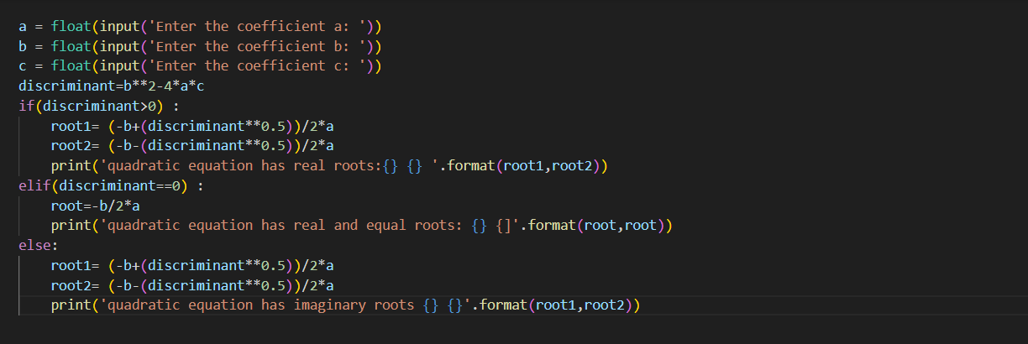

**Output**

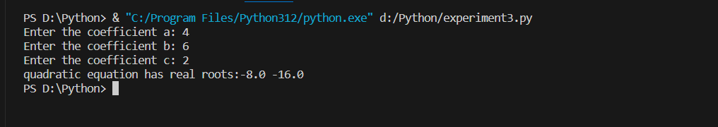

1. **Find whether a given year is a leap year or not.**

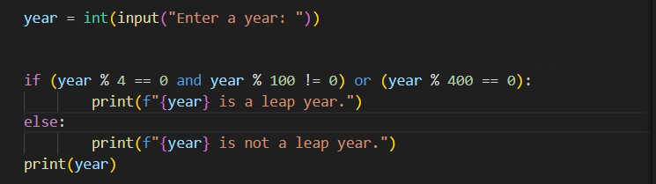

**Output**



1. **Write a program which takes any date as input and display next date of the calendar**

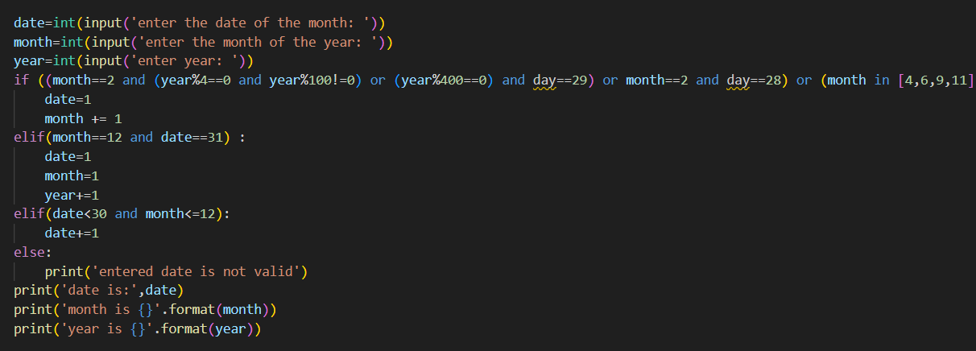

**Output**

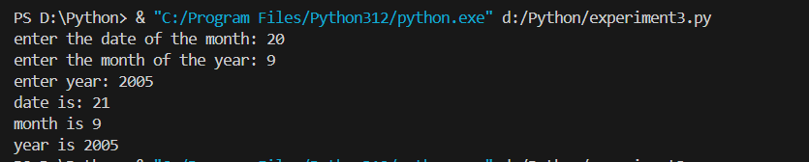

**Experiment 4**

1. **Find a factorial of given number.**

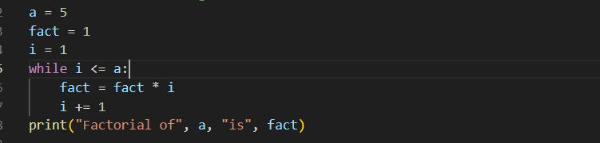

**Output**

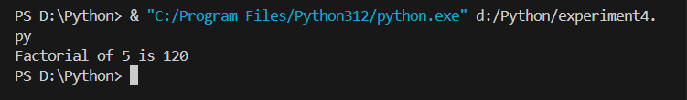

1. **Find whether the given number is Armstrong number.**

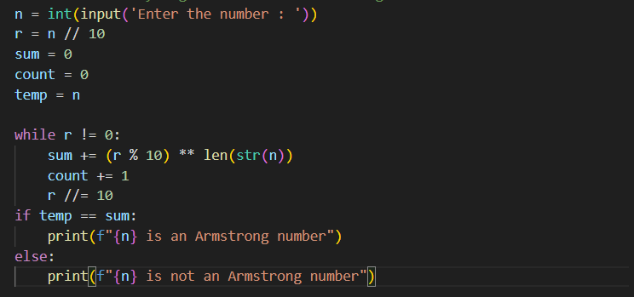

**Output**

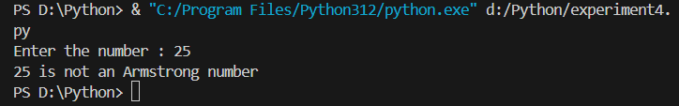

1. **Print Fibonacci series up to given term.**

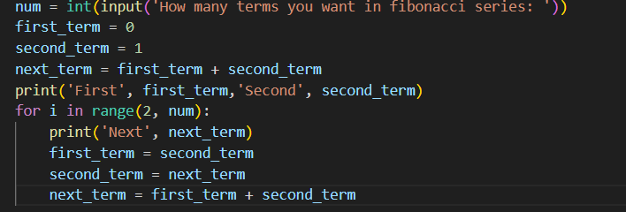

**Output**

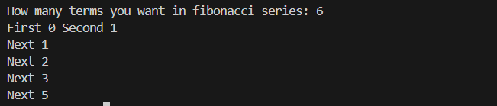

1. **Write a program to find if given number is prime number or not.**

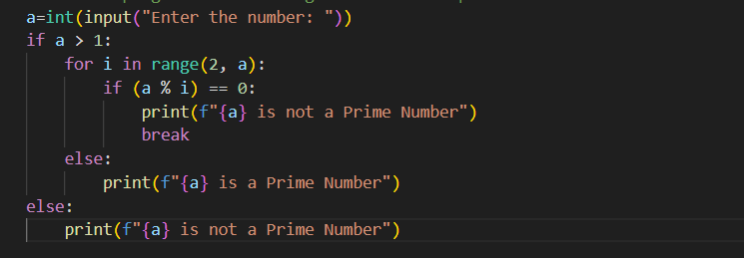

**Output**

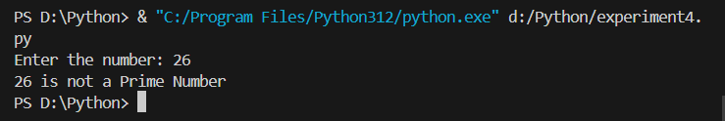

1. **Check whether given number is palindrome or not.**

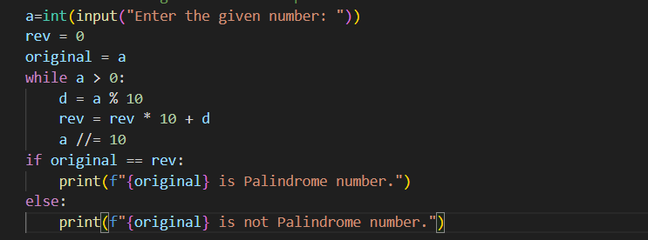

**Output**

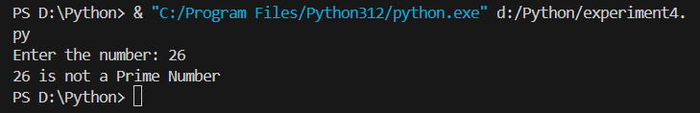

1. **Write a program to print sum of digits.**

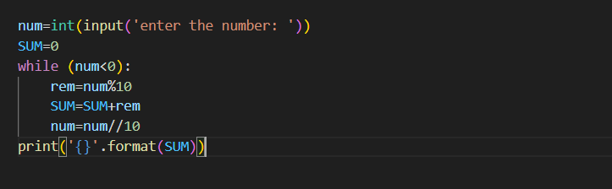

1. **Count and print all numbers divisible by 5 or 7 between 1 to 100.**

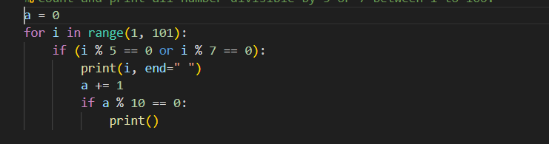

**Output**

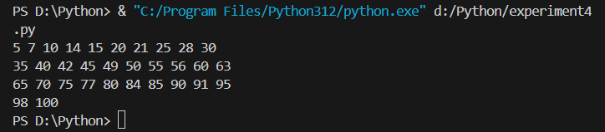

1. **Convert all lower cases to upper case in a string**.

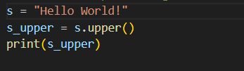

**Output**

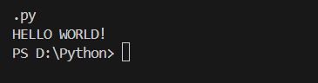

1. **Print all prime numbers between 1 and 100.**

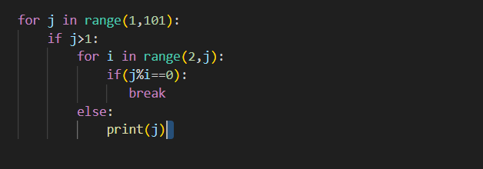

**Output**

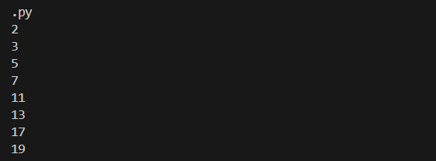

1. **. Print the table for a given number: 5 * 1 = 5 5 * 2 = 10………..**

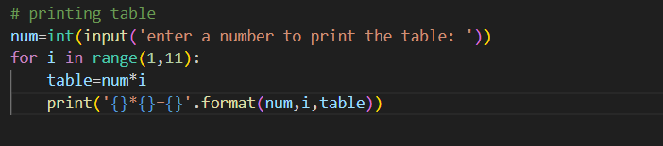

**Output**

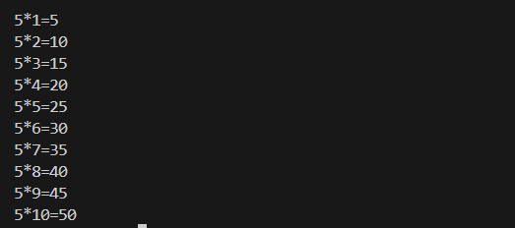

**Experiment 5**

1. **Write a program to count and display the number of capital letters in a given string**

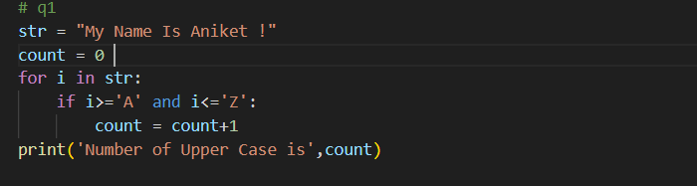

**Output**

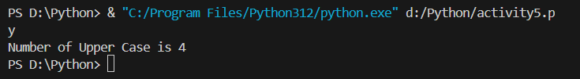

1. **Count total number of vowels in a given string.**

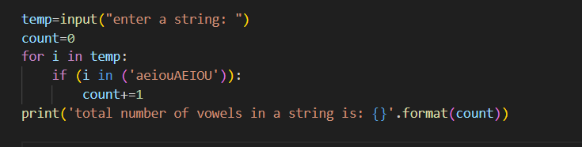

**Output**

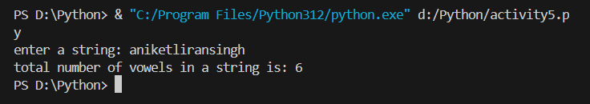

1. **Input a sentence and print words in separate lines.**

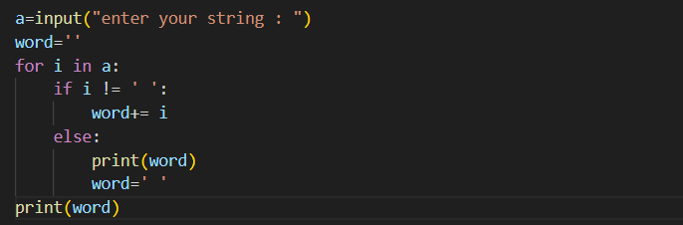

**Output**

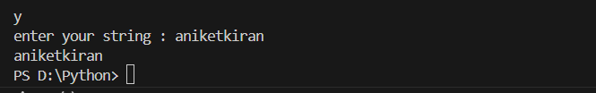

1. **WAP to enter a string and a substring. You have to print the number of times that the substring occurs in the given string. String traversal will take place from left to right, not from right to left.**

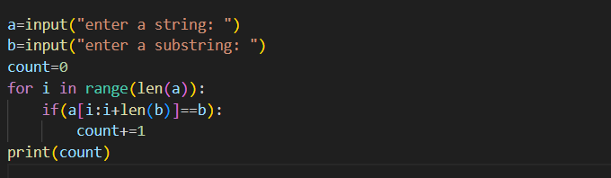

**Output**

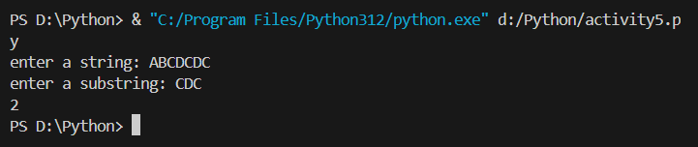

1. **Given a string containing both upper and lower case alphabets. Write a Python program to count the number of occurrences of each alphabet (case insensitive) and display the same.**

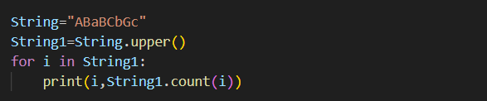

**Output**

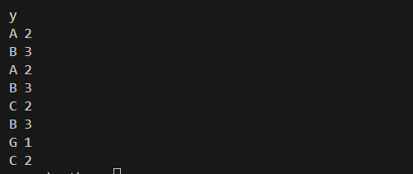

1. **Program to count number of unique words in a given sentence using sets.**

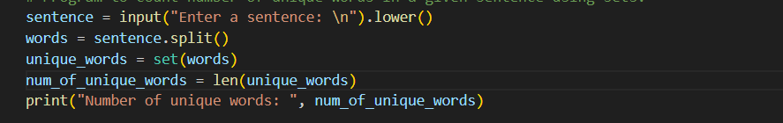

**Output**

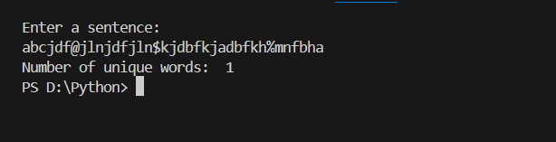

1. **Take two sets and apply various set operations on them : S1 = {Red ,yellow, orange , blue } S2 = {violet, blue , purple}**

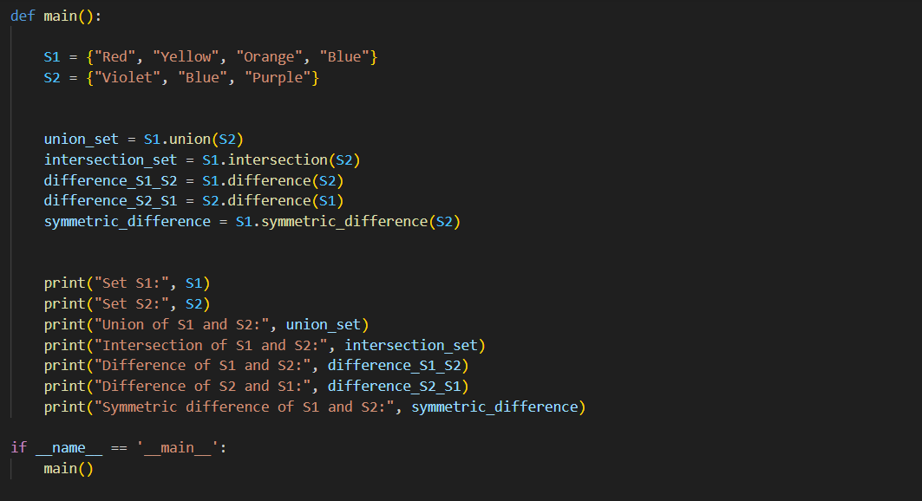

**Output**

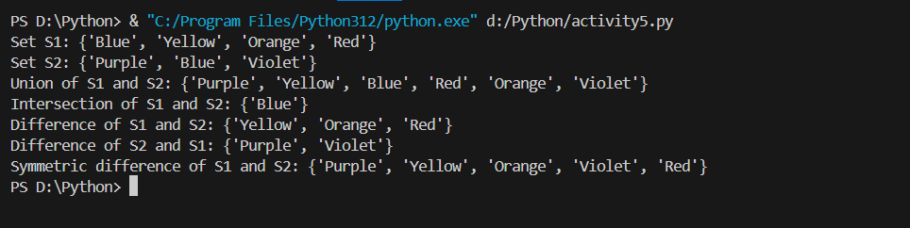

1. **Create 2 sets s1 and s2 of n fruits each by taking input from user and find: a) Fruits which are in both sets s1 and s2 b) Fruits only in s1 but not in s2 c) Count of all fruits from s1 and s2**

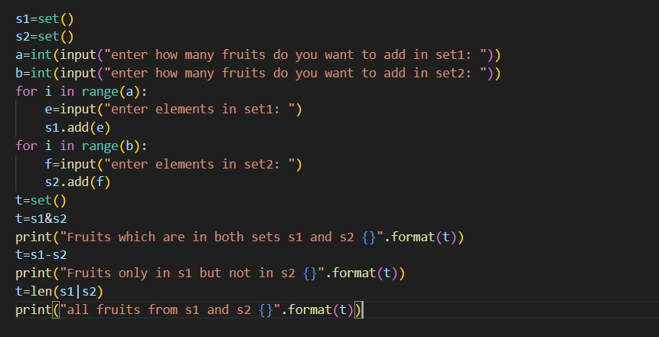

**Output**

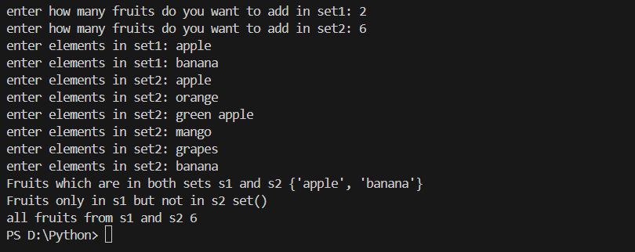

**Experiment 6**

1. **Scan n values in range 0-3 and print the number of times each value has occurred.**

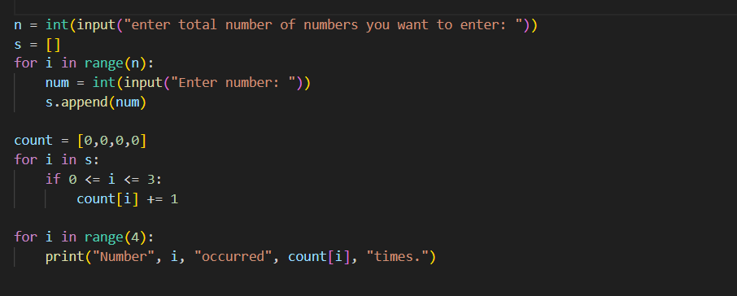

**Output**

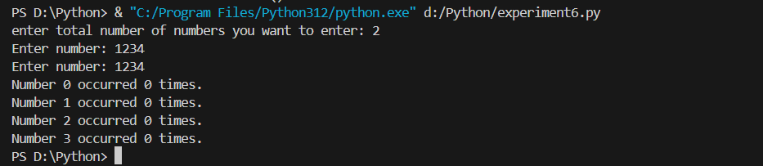

1. **Create a tuple to store n numeric values and find average of all values.** 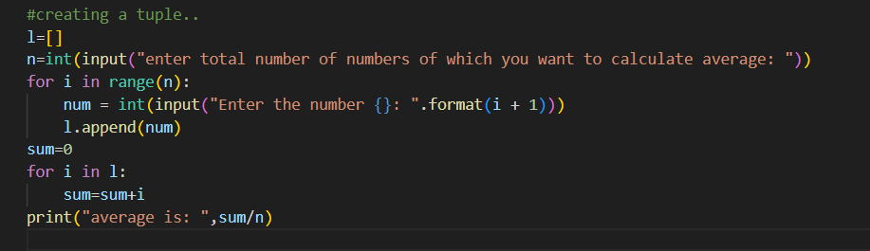

**Output**

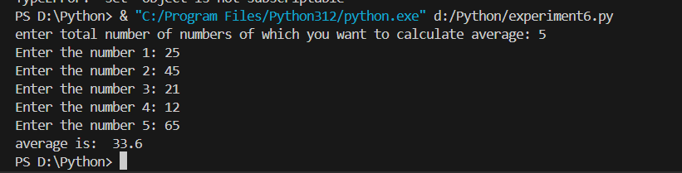

**3.WAP to input a list of scores for N students in a list data type. Find the score of the runner-up and print the output.**

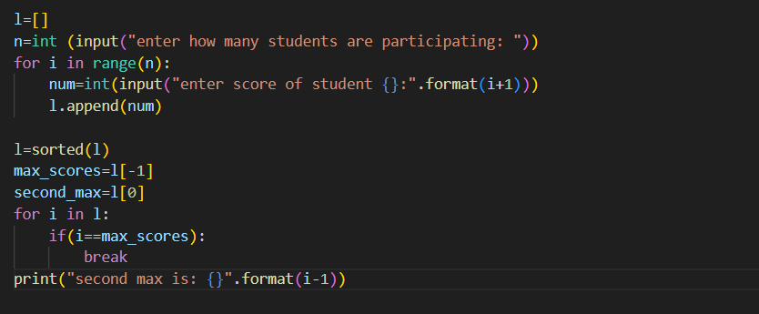

**Output**

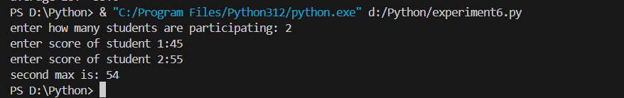

**4.Create a dictionary of n persons where key is name and value is city.**

* 1. **Display all names**
  2. **Display all city names**
  3. **Display student name and city of all students.**
  4. **Count number of students in each city.**

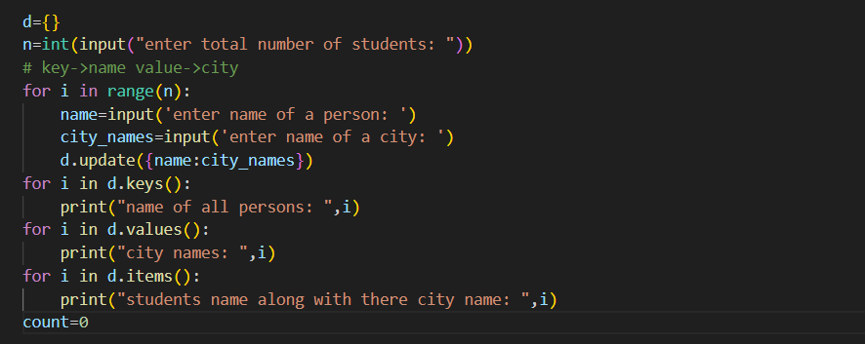

**Output**

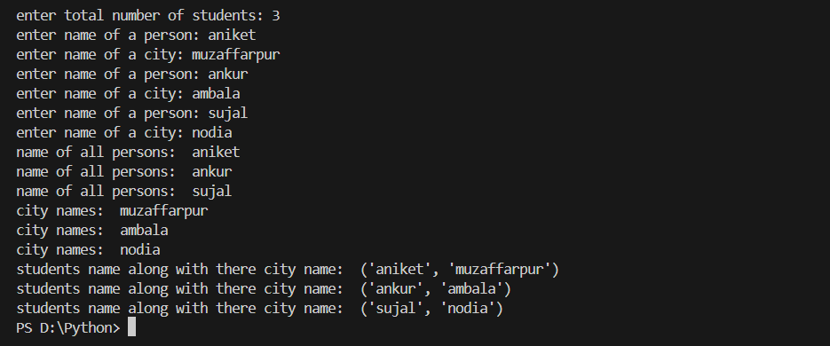

**5.Store details of n movies in a dictionary by taking input from the user. Each movie must store details like name, year, director name,production cost, collection made (earning) & perform the following:- a) print all movie details**

* 1. **display name of movies released before 2015**
  2. **print movies that made a profit.**
  3. **print movies directed by a particular director.**

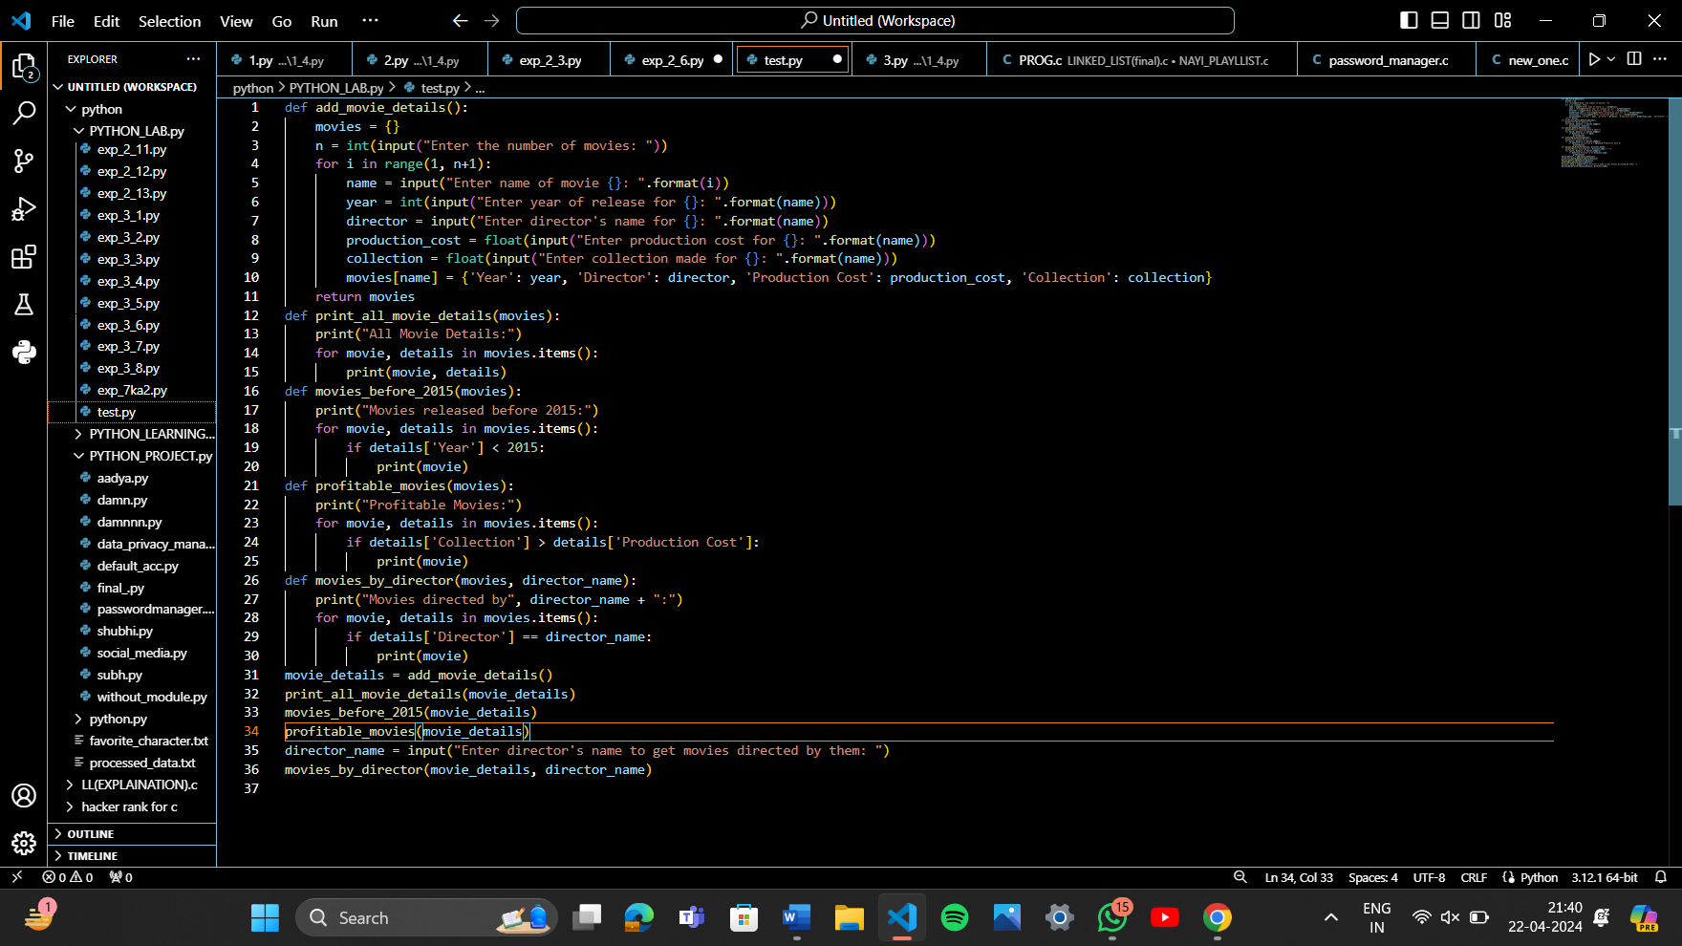

**Experiment 7**

1. **Write a Python function to find the maximum and minimum numbers from a sequence of numbers. (Note: Do not use built-in functions.)**

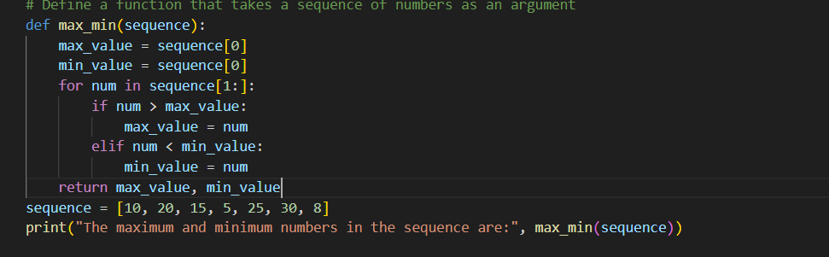

**Output**

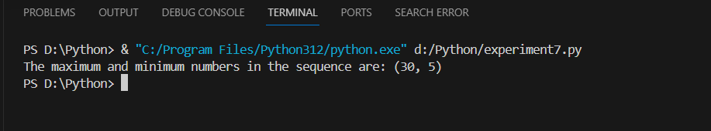

1. **Write a Python function that takes a positive integer and returns the sum of the cube of all the positive integers smaller than the specified number.**

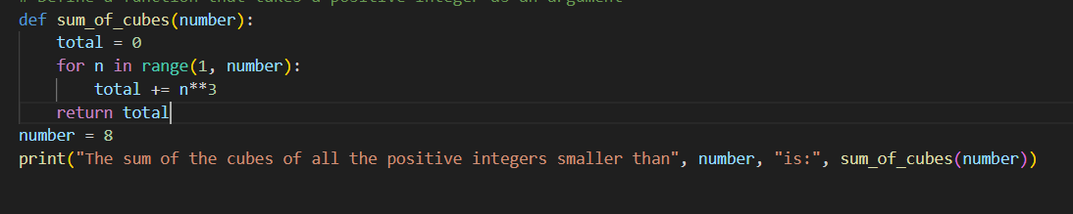

**Output**



1. **Write a Python function to print 1 to n using recursion. (Note: Do not use loop)**

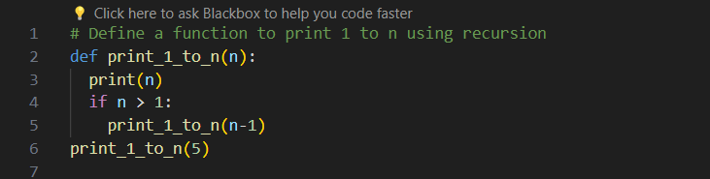

**Output**

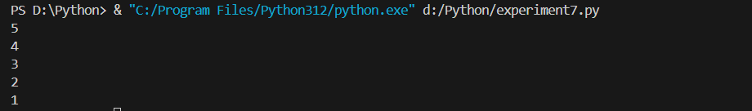

1. **Write a recursive function to print Fibonacci series upto n terms.**

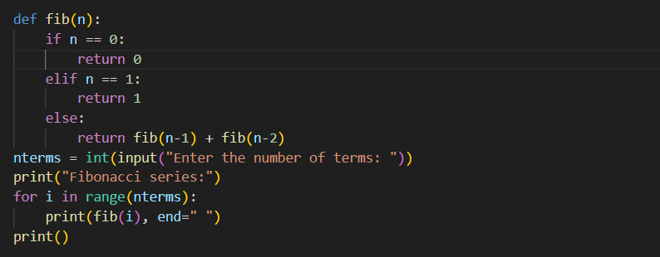

**Output**

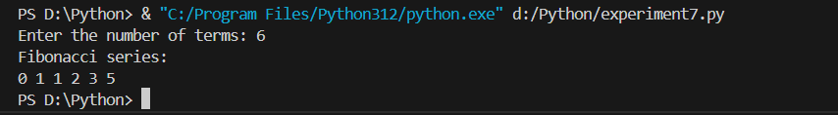

1. **Write a lambda function to find volume of cone.**

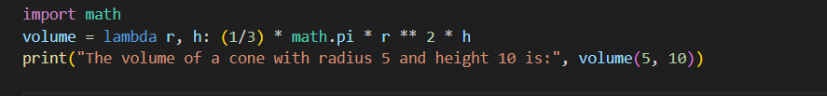

**Output**



1. **Write a lambda function which gives tuple of max and min from a list.**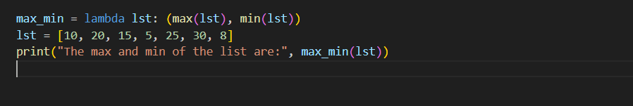

**Output**



1. **Write functions to explain mentioned concepts: a. Keyword argument b. Default argument c. Variable length argument**

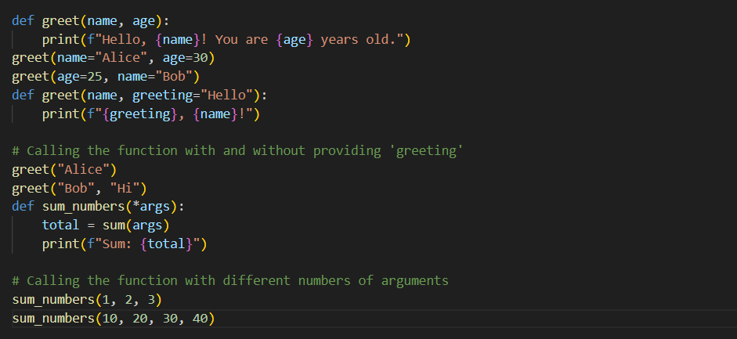

**Output**

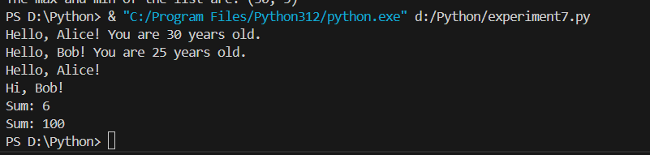

**Experiment: 8**

1. **Add few names, one name in each row, in “name.txt file”. a. Count no of names b. Count all names starting with vowel c. Find longest name**

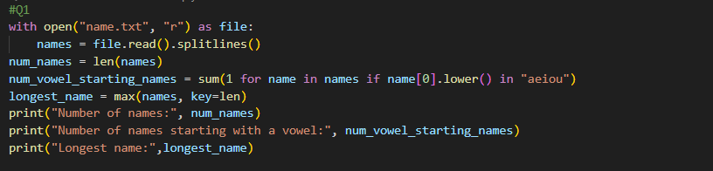

**Output**

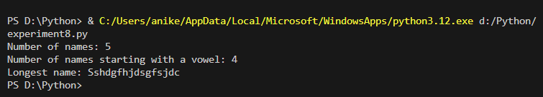

1. **Store integers in a file. a. Find the max number b. Find average of all numbers c. Count number of numbers greater than 100**

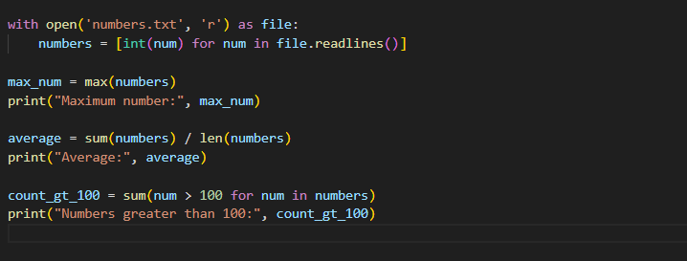

**Output**

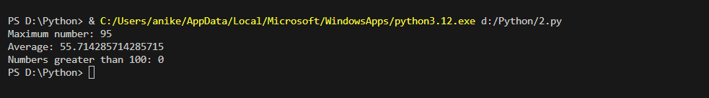

1. **Assume a file city.txt with details of 5 cities in given format (cityname population(in lakhs) area(in sq KM) ): Example: Dehradun 5.78 308.20 Delhi 190 1484 …………… Open file city.txt and read to:**

**a. Display details of all cities**

**b. Display city names with population more than 10Lakhs**

**c. Display sum of areas of all cities**

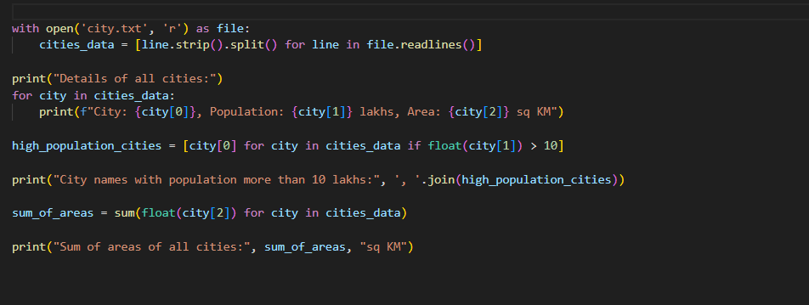

**Output**

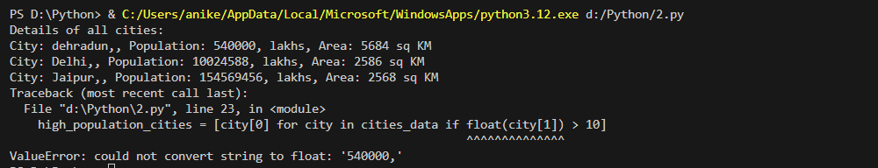

1. **Input two values from user where the first line contains N, the number of test cases. The next N lines contain the space separated values of a and b. Perform integer division and print a/b. Handle exception in case of ZeroDivisionError or ValueError. Sample input 1 0 2 $ 3 1 Sample Output : Error Code: integer division or modulo by zero Error Code: invalid literal for int() with base 10: '$' 3**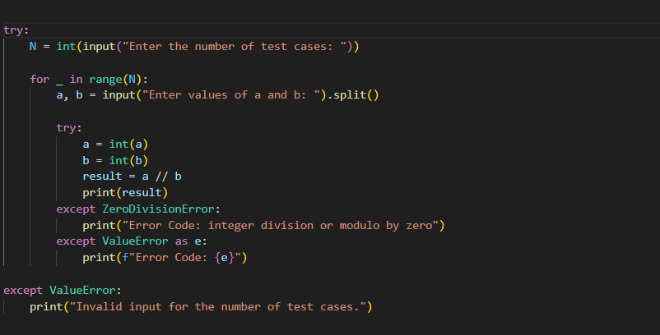

**Output**

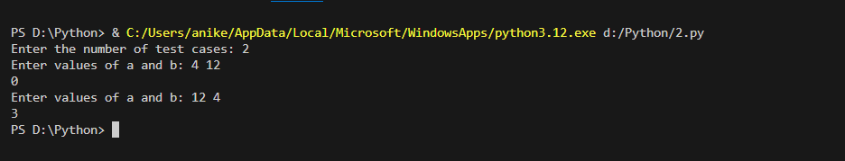

**Experiment 9**

1. **Create a class of student (name, sap id, marks[phy,chem,maths] ). Create 3 objects by taking inputs from the user and display details of all students.**

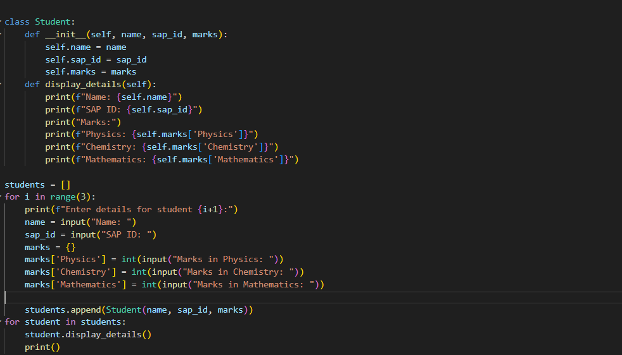

**Output**

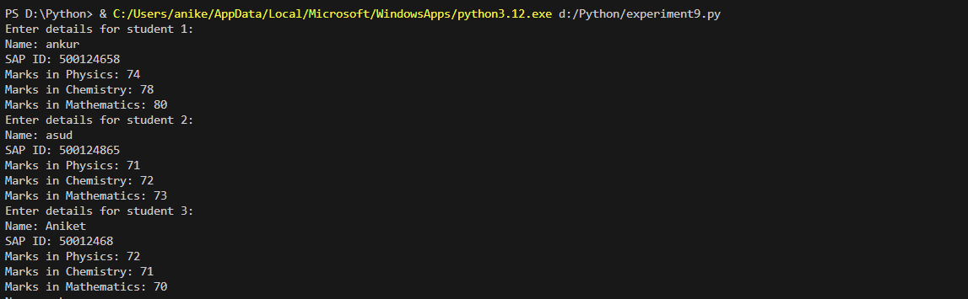

1. **Add constructor in the above class to initialize student details of n students and implement following methods: a) Display() student details b) Find Marks_percentage() of each student c) Display result() [Note: if marks in each subject >40% than Pass else Fail]**

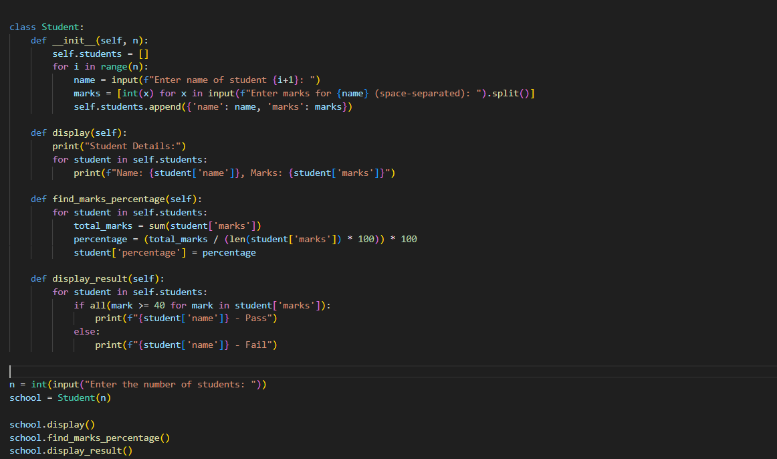

**Output**

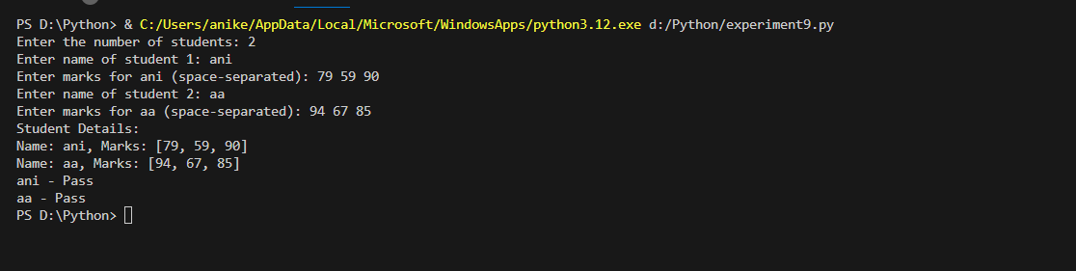

1. **Create programs to implement different types of inheritances.**

**Single inheritance**

**Multiple inheritance**

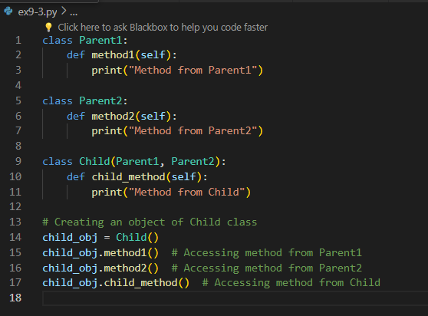

**Hierarchal inheritance**

**Multilevel inheritance**

1. **Create a class to implement method Overriding.**

**OUTPUT**

**5 . Create a class for operator overloading which adds two Point Objects where Point has x & y values e.g. if P1(x=10,y=20) P2(x=12,y=15) P3=P1+P2 => P3(x=22,y=35)**

Output

